Hiking in Greece
Down the Ancient Footpath Into Delphi
This article appears on Matt Barrett’s Greecetravel.com “Hiking in Greece”

People having been coming to Delphi for thousands of years of Greek history and the ancient footpaths they used are still in existence.
By Janet McGiffin
Janet McGiffin is the author of the four-volume Empress Irini series about the 8th Century Byzantine Empress Irini who was one of two women to hold the throne in her own right. Janet can be reached through her website, Janetmcgiffin.com
Dropping gently down the slopes of Mt Parnassos from the Corycean Grotto to the village of Delphi is one of the loveliest day-hikes in the Mediterranean. This well-marked, mapped, 13.7 km route down the mountain sacred to Apollo and Dionysos is a blend of two historic footpaths. One is the Ancient Footpath (Archaio Monopati) that took Pan worshippers up from the ancient temples of Delphi to the Corycean Grotto to celebrate rites of Pan. The second footpath is the European Union E4 Long Distance Footpath that passes over Mt. Parnassos on its way from Gibraltar to Crete.
The Archaio Monopati may be the oldest still-used footpath on the planet. Hewn out of the rock face of Mt. Krokos that rises behind the Delphi archeological site, and wide enough for a donkey cart, the Archaio Monopati led Delphi residents to the Grotto both for Pan and Dionysian worship, and to hide during the Persian invasion, the War of Independence, and during World War II. Delphi itself has been inhabited from 1400 BC.
The E4 Footpath is modern history. As part of the open border agreements of the 1990s, the European Footpaths Commission worked with the countries of the EU to set up twelve cross-Europe footpaths, each publicized and maintained by member countries. Two EU Footpaths cross Greece. The E6 travels east-west from Igomanitsa on the Ionian Sea to Alexandropoli near the Turkish border. The E4 travels north-south from Florina near Albania to Gythio at the tip of the Pelopponese, then skips to Crete.
The E4 crosses the west flank of Mt. Parnassos on the saddle between Mount Giona and Parnassos, at the "51st Km", the highest point of the Lamia-Amfissa Road. The route then passes under the summit to the village of Eptalofos (Agoriani) and meanders down to Delphi with side-trips to various monasteries. Just above Delphi, the E4 merges with the Archaio Monopati coming from the Corycean Grotto.
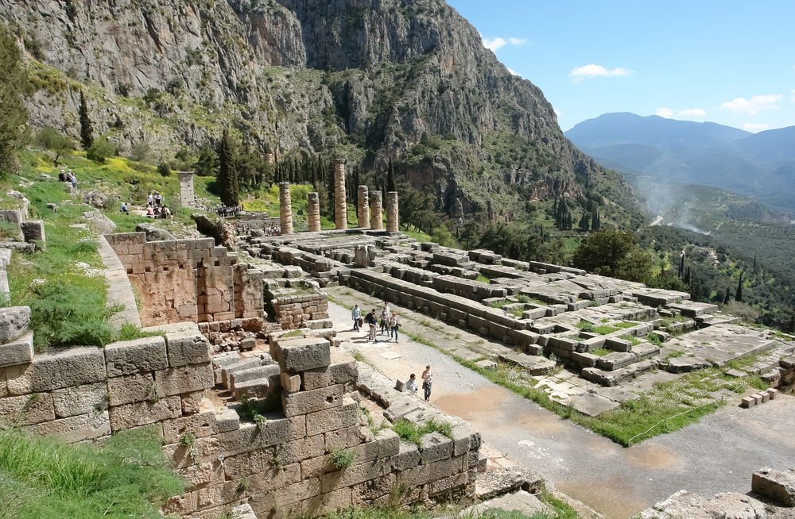
While ancient Greeks worshiping Pan may have wanted to struggle upward to purge their souls, modern hikers can enjoy the Archaio Monopati and the E4 more by hiking downward, by taking a taxi from Delphi for about 45 minutes up Mt. Parnassos to near Kalivia on the Arachova-Agoriani road. A sign indicates the footpath to the grotto. (After passing through a meadow, a sign points right, up a steep slope to the grotto.) Easier is to take the pleasant dirt road that leads directly to the grotto, a half-hour walk.
The dusky and cavernous Corycean Grotto has a satisfying murky echo. Stalactites and stalagmites loom up in the gloom. Named after korikos, a boxing-sack, the Grotto was a cult shrine in Neolithic and late-Mycenaean times. French archeologists in 1970 found cult statuettes, vases, coins, rings, and engravings to Pan and the Nymphs estimated to be 4th to 6th century BC. Above the cave were the Dionysian orgies.
Mornings in late fall or early spring may be foggy or it may appear to be raining on the mountain. Appearances can be deceiving. Drive to the start-off point before making weather decisions. In any case, the hike along the road to the cave is less than an hour. A taxi driver might wait. Or the road can be negotiated by taxi, driver willing. On one Easter hike, we set out in light fog with snow patches but glimpses of Parnassos through the clouds showed a sunny peak. Before long it was shirt-sleeve weather.
From the Corycean Grotto downward to Delphi, the path starts with a sharp descent to pick up the trail leading west. From then on, the grade is gently downward with occasional mild rises. Blazes in black on yellow or red expertly mark the route. At the entrance to Mt. Parnassos National Park, the path passes an information center in a meadow where cattle are pastured.
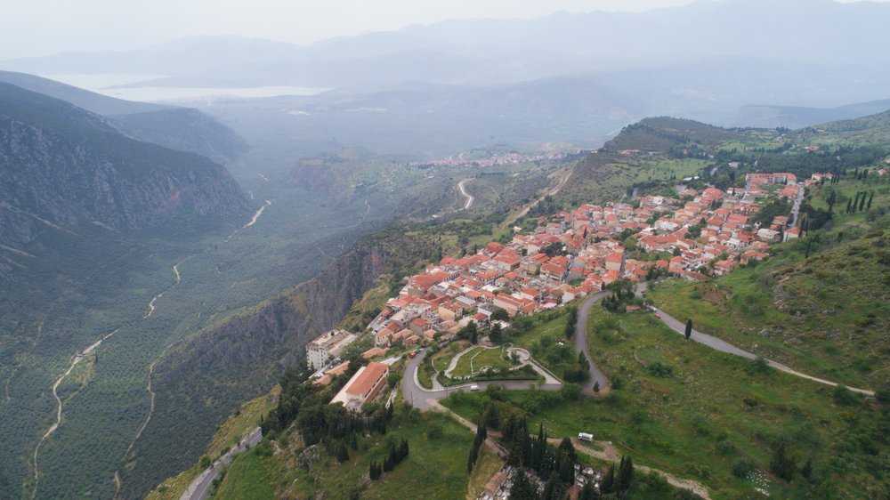
ORGANIZING THE TRIP
Plan for two nights in Delphi, arriving the afternoon before your hike. From Athens, Intercity buses leave from Terminal B on Liossion Street. But there is a lot to see in the area and renting a car may be your best option for exploring. See www.greektravel.com/swift
You can also go by private Taxi from Athens. See www.greecetravel.com/taxi
LODGINGS AND MEALS
Rooms are always available, although Delphi can be crowded in summer and in winter some hotels open weekends only. South-facing rooms overlook the dramatic Pleisto River Gorge and the Peloponnese. Delphi dining is family tavernas serving excellent country fare. Or there is souvlaki at two locations on the main street.
Lodging can also be had in Itea, or Galaxidi on the Gulf of Corinth below Delphi. Arachova, above, is larger and more touristy, and known for picturesque lanes, spectacular views, hotels that also cater to skiers, and the monastery of Ossias Loukas. However, if you've come to hike the Ancient Footpath, your destination will be Delphi, and it's a charming experience to descend the last flight of steps through the town just as the sun is setting, and stroll straight into your hotel. For information and hotels in the towns around Delphi see Matt's Around Delphi Page
TAXI UP THE MOUNTAIN
Reserve your taxi the afternoon before your hike. The taxi stand at the east end of Delphi sometimes has taxis parked there. Or ask your hotel clerk to order a taxi. Pull out your hiking map, point to the Corycean Grotto (Korikio Antro) or the E4 trail and say you want to leave around nine the next morning.
MAPS
Several Greek mapmakers publish excellent hiking maps of Mt. Parnassos (and all of Greece) in Greek and English with detailed information about the hikes and regional history. Maps are found at Athens' bookstores, outdoor equipment stores, or tourist sites. In Delphi, the bus station (the souvlakeria at the west end of Delphi) sometimes has hiking maps.
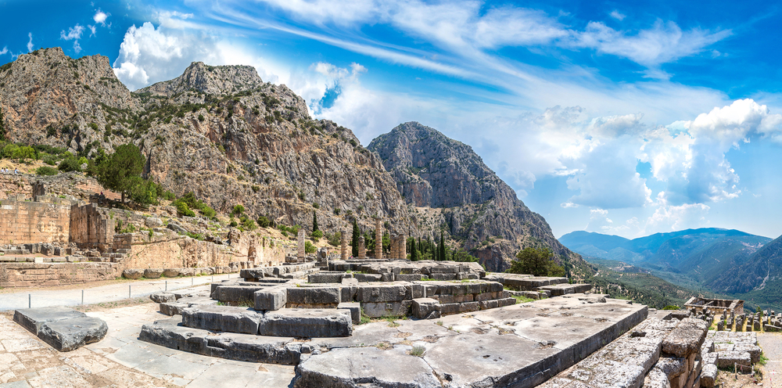
In Greek mythology, Mt. Parnassos was named after Parnassos, a son of Poseidon and the nymph Leonora. Parnassos founded the old oracle of Pith and could tell the future by observing the way birds flew. The mythology gets complicated after that, involving Apollo, Hera (queen of the gods) and a nasty serpentine dragon whom Hera liked named Python who lived by the Kastalia springs at Delphi and destroyed men and beasts. The cult of Apollo eventually took over and resulted in the Oracle of Delphi and the oracle’s famous predictions. In a parallel myth, Dionysos, son of Zeus and Persephone, lived on Parnassos and was pursued by Hera. Complications of Greek mythology aside, there's definitely something about this part of the "Middle Earth" that puts Delphi on the maps of even eastern religions who consider it an energy point of the universe.
Mt. Parnassos National Park was set up in 1938, 36 million square meters of protection for the unusual ecosystem of the mountain. Bauxite deposits are plentiful and Parnassos bauxite remains the main primary material for Greek aluminum production. Below 700 meters of altitude grows Mediterranean vegetation which needs little water--thyme, oregano, Holm-oak, cedar, arbutus, laurel, lentisk. Olive groves carpet the foot of the mountain, especially in the Pleisto River valley below Delphi and the Itea plain. Between 700 and 1,000 meters grow forests of pine and Kephallonian firs with their sharp needles. Above timberline is little but rock.
Depending on bird migration patterns, hikers may see thrushes, linnets, woodpeckers, and robins. Higher are orioles and birds of prey that nest among the rocks such as vultures, harrier eagles, and golden eagles.
The trail meanders through woods that are masses of bright leaves in autumn, and glades that are carpeted with wildflowers and snow patches in spring. Small waterways are the water sources for Delphi and the Kastelia Springs by the archeological site. Lovely views open unexpectedly to Mt. Parnassos and the mountains to the West.
Armed with a map, the hiker can choose between two routes. One leaves the Archaio Monopati shortly after the National Park entrance and heads west to catch the E4 trail. It is a dirt road. The second route is a path that turns downward to follow the Archaio Monopati and then slope south-west to merge with the E4 lower down.
Since I first wrote this article, the part of the footpath that turns downward off the road to the E4 has become a mountain bike trail used for competition races and flagged with yellow strips of plastic. The races have nearly destroyed the footpath and it is difficult to pick through the broken trees and find your way. I now recommend that you continue on the dirt road until it connects to the E4. This is marked on maps.
Or omit the cave and ask your taxi driver to take you as far as he can to where his road connects with the E4, then hike down from there. It is still a marvelous hike.
The arrival at the top of the cliff above Delphi is so abrupt as to be startling. From a tunnel-like gully lined with white rocks, the vista explodes outward. If the timing has been right, the sun is just lowering over the Ionian Sea, silhouetting the mountains to the west. To the south, the Gulf of Corinth is a slice of silver below the purple mountains of the Peloponnese. To the left are the twin Phaedriades (Shining Rocks) so called because they reflect the light. There the ancients threw off people convicted of sacrilege. Straight down are the tiny red tile roofs of Delphi and the final zig-zags of the Archaio Monopati.
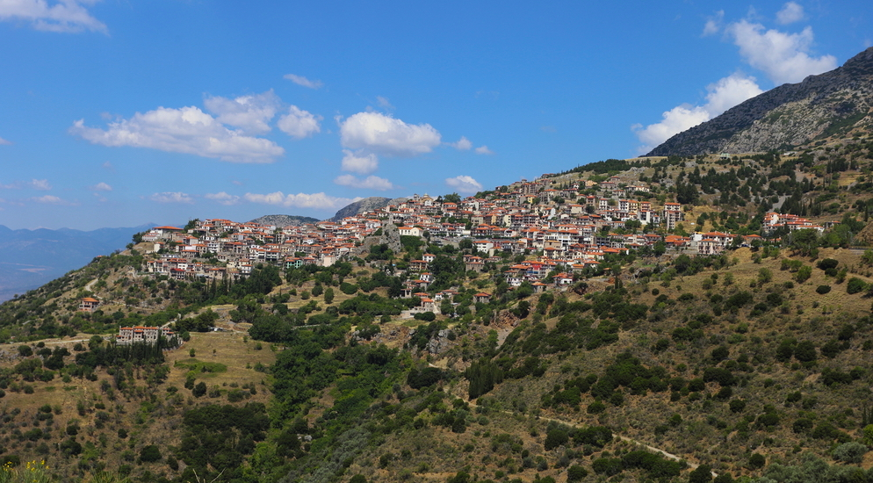
CONTINUE THROUGH DELPHI TO ITEA
A lovely day-walk through the ancient olive groves below Delphi is well worth taking. You continue down the E4 from Delphi down a well-marked path through villages and extraordinary olive groves to Kirra, the ancient port next to the modern village of Itea. This was the route taken by pilgrims to the Delphi Oracle. Kirrha has an interesting history. About 590 BC, several Greek city-states joined to protect the sanctuary of Delphi. According to one historian, they attacked Kirrha which controlled the road to Delphi. Kirrha had appropriated land considered sacred to Apollo and had mistreated pilgrims. Following an edict from the Oracle of Delphi to destroy the town, the commander of the siege cut the water-pipes leading into the town. When townspeople were suffering seriously from thirst, he turned on the water again, but poisoned with hellebore. The ensuing diarrhea so weakened the town that it was overcome.
To return to your hotel in Delphi, stroll along the promenade to Itea, perhaps stopping at one of the many excellent seafood restaurants and take the bus up to Delphi from the bus stop by a superb bakery. Or take a taxi from the taxi rank near the bus stop.
OTHER HIKES AROUND DELPHI
(I have not taken these but they are well mapped and described in hiking guides)
For continuing up Mt. Parnassos from the Corycean Grotto, the ascending footpath is picked up at Kalivia where the trail crosses the Arachova-Agoriani road (the same drop-off for the Grotto-to-Delphi hike). This marked and mapped footpath proceeds upwards to the village of Livadi, the mountaineering club shelter, and the Tgerontovrachos hills, crossing the winter sports centers. Two detours lead to the Parnassos and Liakoura Gerontovrachos peaks. The path descends through the Velitsa Gorge to the village of Tithorea.
A second route follows the path taken in the old days by the villagers of Arachova and Apo Souvala to ascend to the higher slopes of Parnassos. This path is said to be partly destroyed.
Hikers can descend the entire Parnassos portion of the E4, starting at the "51st Km" and ending at Kirrha on the Gulf of Corinth. The distance is approximately 60 km and could be walked in three days with overnights in Agoriani, Delphi, and Kirra.
To the Sybaris Cave and the Pleisto Gorge. This descends an earth road leading from the main road East of Marmaria. Some guidebooks have details.

